**Working of a PC Motherboard**

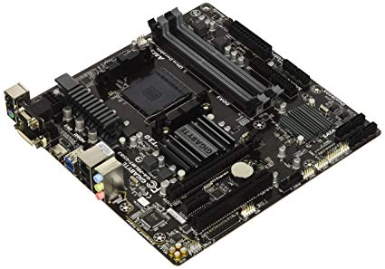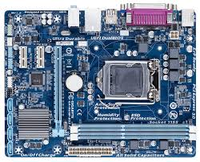

**First Step**: - Connecting the fully Assembled PC to a power source.

Images from google search (search term: Motherboard)

**Second Step**: - Switching on the Power Button.

**Third Step** - When the computer is powered, the first thing that processor does is look for instructions. For the instruction it refers to the system ROM, more precisely the BIOS (Basic Input-Output System) and does those instructions. The first instruction in the BIOS is POST.

**Fourth Step**: - POST (Power-On-Self-Test) is a computer programs within the BIOS to check missing essential hardware or hardware failure. Then the BIOS shows the information on the monitor about the boot process, showing BIOS manufacturer, version number, details about processor, RAM, storage devices, I/O devices connected. It also shows warnings and errors. There is also a beep speaker that beeps while booting up, usually a single beep means nothing’s wrong, different no of beeps means different errors that varies from manufacturer to manufacturer.

**Fifth Step**: - The BIOS attempts to access the first sector of the drive designated as the boot disk. Usually the drive with the lowest number is the boot Disk. The boot disk is typically the same hard disk or solid-state drive that contains your operating system. You can change the boot disk by configuring the BIOS or interrupting the boot process with a key sequence like ‘f10’ or ‘DEL’ (often indicated on the boot screens).

**Sixth step:** - The BIOS confirms there's a boot loader, in the boot disk, and it loads that boot loader into memory (RAM). The boot loader is a small program designed to find and launch the PC's operating system. Once the boot loader is loaded into memory, it starts loading the operating system into the memory.

**Finally** when the boot loader finishes its task, the operating system gains control of the PC, and hence the booting process completes.